Cost Function

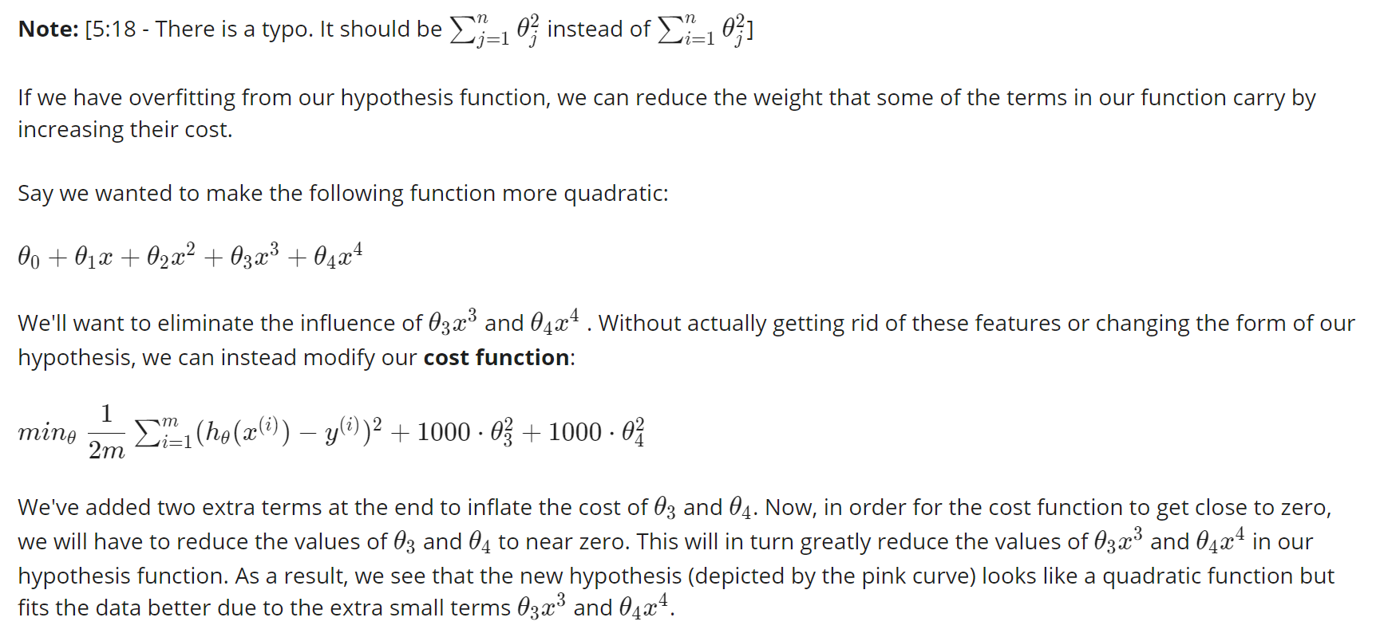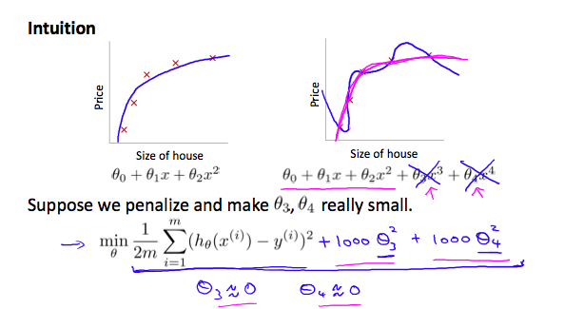

We could also regularize all of our theta parameters in a single summation as:

The λ, or lambda, is the **regularization parameter**. It determines how much the costs of our theta parameters are inflated.

Using the above cost function with the extra summation, we can smooth the output of our hypothesis function to reduce overfitting. If lambda is chosen to be too large, it may smooth out the function too much and cause underfitting. Hence, what would happen if *λ*=0 or is too small ?